PHYSICS 11:(2AB)
Forces and Energy Test 2012

Name: ____________________________________

Time: 1 Hour

* A data sheet is supplied for student use

Note:
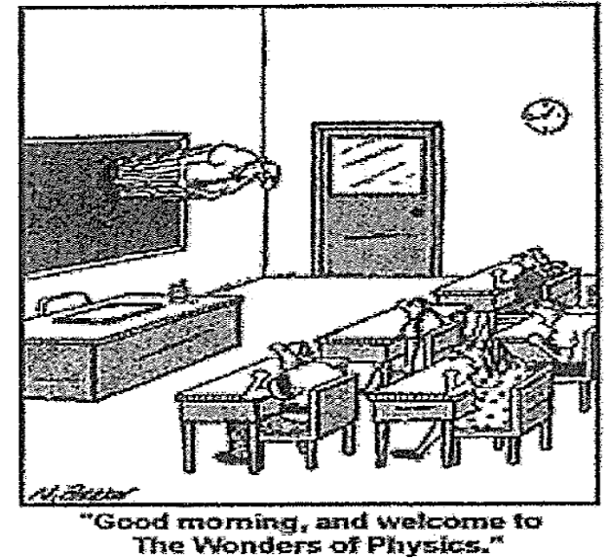
- Calculations must show clear working with answers written in scientific notation stated to three significant figures..

- Full Marks will be allocated for clear and logical setting out.

- To help identify your answer, underline each answer.

- State assumptions if working on open ended type questions.

5. Not all questions carry equal number of marks.

1. (3 marks)
A skydiver with a parachute has a total mass of 80.0 kg experiences an air resistance of
5.10 x 10² N while free-falling. Calculate the resultant acceleration of the skydiver.

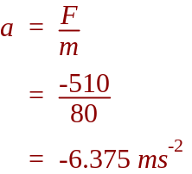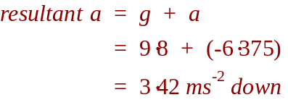

2. (2 marks)
What is the work done by the brakes of a 1.50 x 10 ³ kg car as they slow the car from
2.50 m s⁻¹ to 1.00 m s⁻¹ over a distance of 8.00 m?

Note: two methods to solve

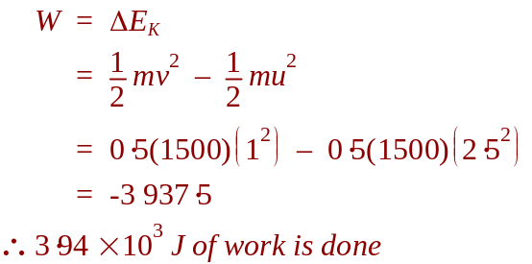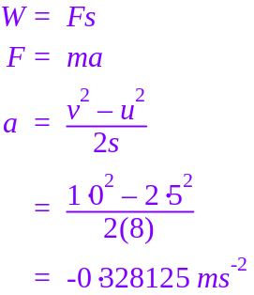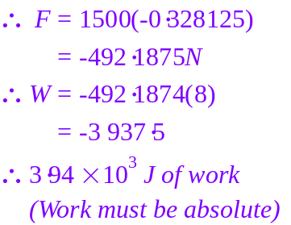

3. A 10.0 kg ball falls from a height of 5.00 m and rebounds from the floor to a height of
3.00 m.

(a) (2 marks)
Calculate the energy lost by the ball?

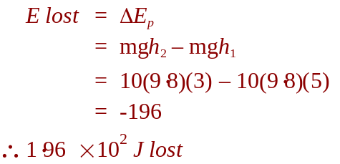

(b) (2 marks)
What happens to the energy lost by the ball?

Energy is lost upon impact to heat and sound.
Energy is also lost when the ball is moving through the air due to air resistance.
4. A sketch of a rock thrown on the moon’s surface
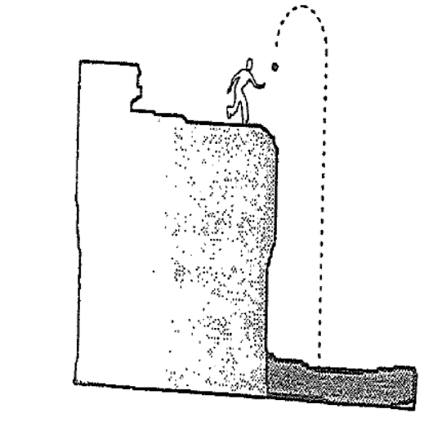

An astronaut throws a rock vertically upwards on the lunar surface with a velocity of
15.0m s⁻¹ , given that the moon’s ‘g’ value is 1.60 m s⁻² , determine the following.

(a) (2 marks)
The time it would take the rock to reach its maximum height.

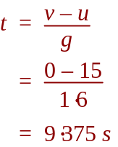

(b) (2 marks)
The height the rock reached above its point of release.

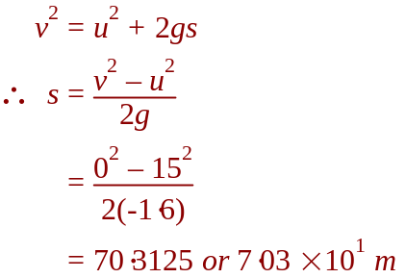

(c) (2 marks)
The rocks final velocity just before it impacts on the valley floor below. (82.0 m below the release point).
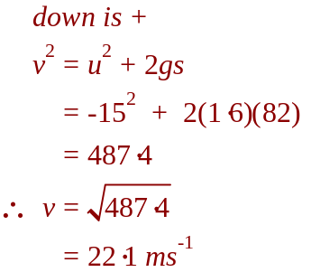
5. (a) (2 marks)
Tim visited a rifle range and found that a rifle tends to ‘kick’ after it is fired.
Use the correct Newton’s law to explain why it does this.

Newton’s 3rd Law – every action has an equal but opposite reaction.
When firing, a force is applied to the bullet and to the gun. Therefore the gun will accelerate in the opposite direction to the bullet.

(b) (2 marks)
Most buses have vertical steel poles attached to the seats and ceiling. Use the correct
Newton’s law to explain why this pole is there for standing passengers.

Newton’s 1st Law – objects will continue under constant motion unless acted upon by an external force.
When held onto, the vertical pole provides this force.

6. (3 marks)
A car of mass 1.30 x 10³ kg has a caravan of mass 9.00 x 10² kg attached to it. The car and caravan move off from rest.

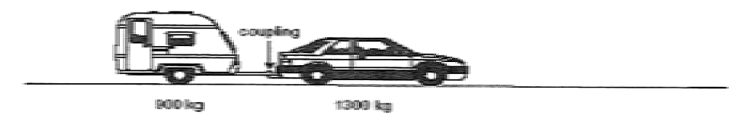

If the car engine produces a forward force of 2.70 x 10³ N, what is the tension in the coupling between the car and the caravan as they start to accelerate?

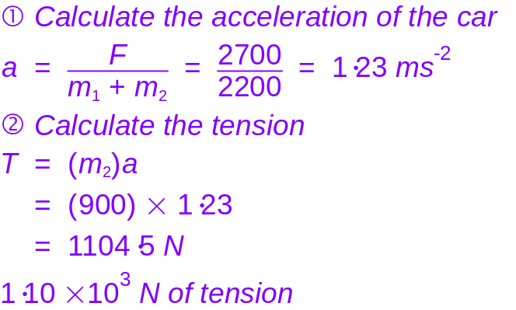

7. A cart of mass 18.0 kg is being held in place on a 40.0º FRICTIONLESS slope by a cable which is parallel to the slope.
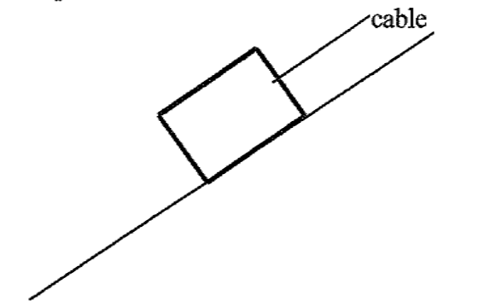

N

W

(a) (2 marks)
Draw a free body diagram in the box above showing all the forces acting on the block.

(b) (3 marks)
What is the tension in the cable needed to hold the cart in place on the
slope?
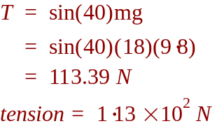

(c) (3 marks)
When the cable breaks, it is found that it takes 1.40 s for the cart to
Reach the bottom of the slope. How far up the slope was the cart
originally?

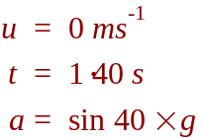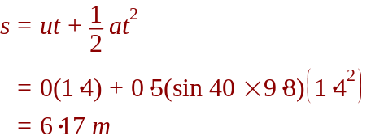

8. (3 marks)
A car of mass 1.40 x 10³ kg has a head-on collision with a large four-wheel drive vehicle of mass 2.20 x 10³ kg, after which both cars stop. The four-wheel drive vehicle was travelling at 50.0 km h⁻¹ prior to the collision in an area where the speed limit was 70.0 km h⁻¹. Was the car speeding? Show working below to verify the car’s velocity immediately before collision.

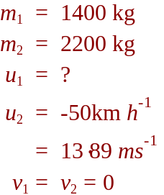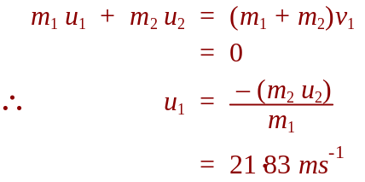

9. A driver with a mass of 80.0 kg is driving a car of mass 1.85 x 10³ kg at 90.0 km h⁻¹ and crashes into a concrete wall. In the collision the car comes to rest.

(a) (2 marks)
What is the car’s change in momentum?

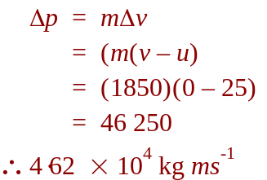

(b) (2 marks)
What impulse does the car undergo?

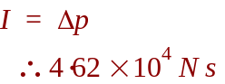
(c) (2 marks)
If the car was stopped in 5.00 ms by the wall, what was the average force acting on the car?

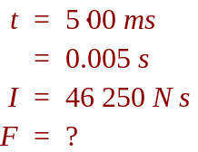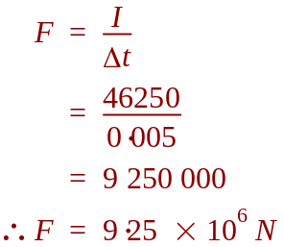

(d) (2 marks)
Calculate the force on the driver during the collision.

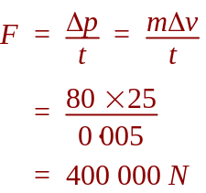

(e) (4 marks)
What are two examples of safety features that are designed to reduce the force of impact on the driver? Explain how they reduce the force on the driver.

Seatbelts, to provide a force to stop motion (Newton’s first law)
Crumple zones/air bags, to increase stopping time, reducing force (Newton’s second law)

END OF TEST

